Cultures of Voting in the Mediterranean (ca.1200-1700)
Croatian Academy of Sciences and Arts, Institute for Historical Sciences in Dubrovnik (Zavod za povijesne znanosti HAZU u Dubrovniku)
Dubrovnik, 25-26 April 2014
Programme

Friday 25th April – Institute for Historical Sciences, Lapadska obala 6

9.00-9.15 Registration

9.15-9.45 Introduction (Serena Ferente and Lovro Kunčević)

9.45-11.00 Session One: Florence and Genoa (Chair: Miles Pattenden)

Lorenzo Tanzini: From discussion to vote. Practices of political deliberation and written records in communal Italy (read by Lovro Kunčević)

Serena Ferente: Elections and parties in fifteenth-century Genoa

11.15-12.45 Session Two: Venice (Chair: Serena Ferente)

Maartje Van Gelder: Voting for a new doge. The electoral politics of the ducal vacancy in Venice

Maud Harivel: Golden, coloured and linen balls: material aspects of the political elections in the Doge´s palace of Venice

13:00-13:30 Transfer to Center for Advanced Academic Studies, Don Frana Bulića 4

13.30-14.30 LUNCH at The Sesame Tavern, Don Frana Bulića 7

14.30-16.00 Session Three: Dalmatia (Chair: Lovro Kunčević)

Nella Lonza: Cultures of voting in medieval Split: models and practices

Zrinka Pešorda: Voting and election in the elite Ragusan confraternities of St. Anthony and St. Lazarus (14th-16th c.)

16.15-18.30 Session Four: Mediterranean Monarchies (Chair: Miles Pattenden)

Pierluigi Terenzi: The citizens and the King: Voting and elections procedures in south-Italian towns under the Aragonese

Vicent Baydal: Voting in the Parliament of Catalonia (14th-16th c.)

Alexandr Osipian: Voting on the move: elections of caravanbashi by Armenian merchants trading in the Ottoman Empire

20.30 DINNER at Restaurant Kopun, Poljana Ruđera Boškovića 7 (Old Town)

Saturday 26th April – Institute for Historical Sciences, Lapadska obala 6
10.00-12.15 Session Five: Voting in the Church (Chair: Serena Ferente)

Vesselina Vachova: Let's vote for the New World Order: procedural, administrative, legal and ideological dimensions of the Dardanelles meeting in 1235

Alex Russell: Popular involvement in ecclesiastical elections: theories and practices in the Western Church (1378 - 1462)

Miles Pattenden: Cultures of secrecy in the Papal Conclave

12.30-13.00 Roundtable Discussion (Chair: Miles Pattenden)

13.30-14.30 LUNCH at The Sesame Tavern, Don Frana Bulića 7

List of participants:
Vicent Baydal (Oxford University)
Serena Ferente (King’s College London)
Maud Harivel (University of Bern/ Ecole Pratique des Hautes Etudes)
Lovro Kunčević (Croatian Academy of Sciences and Arts)
Nella Lonza (Croatian Academy of Sciences and Arts)
Alexandr Osipian (Kramatorsk Institute of Economics and Humanities)
Miles Pattenden (Oxford Brookes University)
Zrinka Pešorda (Croatian Institute of History)
Alex Russell (Warwick University)
Lorenzo Tanzini (University of Cagliari)
Pierluigi Terenzi (University of Milan)
Vesselina Vatchkova (National Academy of Arts, Sofia)
Maartje Van Gelder (University of Amsterdam)

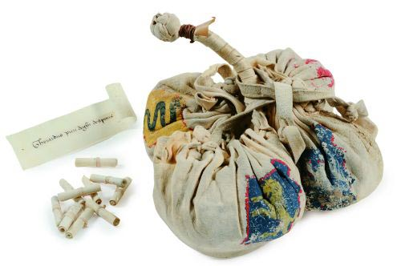

Image: Electoral bags and polizze with the names of those eligible to the office of the Priorate in Florence, 15th c.
© Archivio di Stato di Firenze

