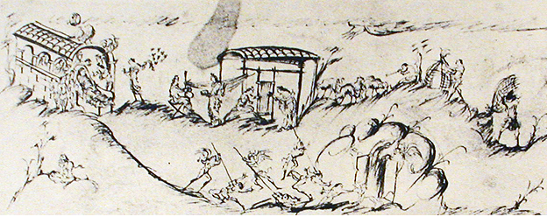

Domesticity in the Anglo-Saxon World

5 March 2012
12:00-17:00

At the historic John Rylands’ Library, Deansgate
(MANCASS Toller lecture to follow)

Keynote Speaker: Dr Jonathan Wilcox, University of Iowa

Curious about Anglo-Saxon marriage? Interested in daily life as found in the iconography of saints lives? Perhaps Anglo-Saxon textiles or animal husbandry intrigues you. Join us at the MANCASS annual post-graduate conference to learn more (or join the conversation by presenting a paper).

RSVP to be sent to Christina Petty at christina.petty@postgrad.manchester.ac.uk

