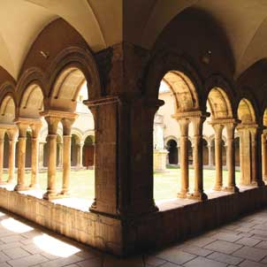
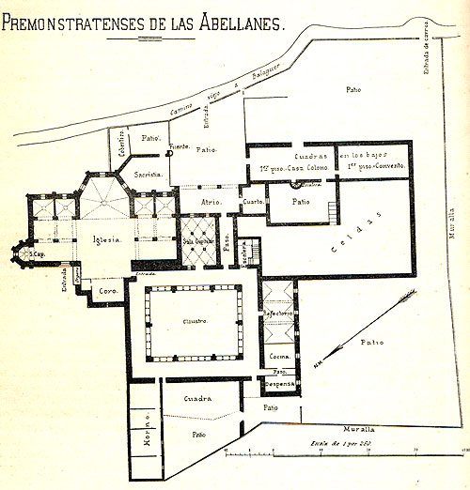

Monacat femení
Monestir de Santa Maria de Bellpuig de Les Avellanes
4 i 5 de juliol de 2011

Professors convidats:
Janet Burton, Guido Cariboni, Michael Carter, Goya Cavero, Tracy Collins, Carmen Florea, Michèle Gaillard, Brian Golding, Erin Jordan, Núria Jornet, Brian Patrick McGuire, Anne Müller, Anna Rapetti, Hedwig Röckelein, Matthias Untermann

Programa

4 de juliol de 2011

9,00h-11,00h. Primera sessió.
FUNDACIÓ, IDENTITAT I AUTORITAT

- Dr. Guido Cariboni (Università Cattolica del Sacro Cuore), Cistercian
nuns in northern Italy. Variety of foundations and construction of an
identity.

- Prof. Goya Cavero (Universidad de León), Monacato femenino español: conventos familiares femeninos y su evolución (siglos XI-XII)

Pausa-cafè

11,30h-13,30h. Segona sessió.

- Prof. Janet Burton (University of Wales Trinity Saint David), Female religious communities and male authority

- Prof. Michèle Gaillard (Université de Lille-3), Monastères féminins du haut Moyen Âge entre Seine et Rhin

Debat

16,00h-18,00h. Tercera sessió
EL MONACAT FEMENÍ REGIONAL

- Dr. Anna Rapetti (Università di Venezia), Women and monasticism in Venice, X-XII centuries

- Prof. Brian Golding (Southampton University), Forms of the cura monialium in 12th and 13th century England

Pausa-cafè

18,30h-20,00h. Quarta sessió

- Prof. Brian Patrick McGuire (Roskilde Universitet), Cistercian nuns in medieval Denmark and Sweden: Far from the Madding Crowd?

- Dra. Núria Jornet (Universitat de Barcelona), La espiritualidad mendicante en femenino en tierras Catalanas: el nacimiento de las primeras comunidades clarisas.

Debat

5 de juliol de 2011

09,00h-11,00h. Cinquena sessió
ART, ARQUITECTURA I ARQUEOLOGIA

- Dra. Tracy Collins (University College Cork), Medieval nunneries in Ireland: An archaeology

- Dr. Michael Carter (Courtauld Institute), Silk Purse or Pig's Ear? Swine Priory and the Art and Architecture of Northern English Cistercian Nunneries at the End of the Middle Ages

Pausa-cafè

11,30h-13,30h. Sisena sessió

- Dra. Carmen Florea (“Babes-Bolyai” University, Cluj), “For they wanted us to serve them…” Female monasticism in medieval Transylvania

- Prof. Hedwing Röckelein (Georg-August-Universität Gottingen), FemMoData-A database on medieval female monasteries in Europe

Debat

16,00h-18,00h Setena sessió
ESPAI SIMBÒLIC

- Dra. Erin Jordan (University of Northern Colorado), Neither male nor female in Christ: Gender, space and Cistercian nunneries in thirteenth-century Flanders

- Dra. Anne Müller (University of Wales Trinity Saint David), Symbolic meaning of space in female monastic tradition

- Prof. Matthias Untermann (Universität Heidelberg), Der Ort des Chorgebets in Frauenklosterkirchen

Debat

